STAFFORDSHIRE
RUGBY UNION Ltd.

ANNUAL
REPORT
2023-2024

STAFFORDSHIRE RUGBY UNION LIMITED

Notice is hereby given that the Twenty-Fifth Annual General Meeting of Staffordshire Rugby Union Ltd. will be held at:
COOPERS PARK
STAFFORD RUGBY UNION FOOTBALL CLUB
BLACKBERRY LANE, STAFFORD
on TUESDAY 25th JUNE 2024
at 7.30 p.m.
AGENDA
1. Apologies.

2. Minutes of SRU AGM 2023.

3. To read and approve the SRU Annual Report for the season 2023-24.

4. To elect the following Officers for Season 2024/2025.
- President.
- Chairman.
- Honorary Secretary.
- Honorary Treasurer.

5. To elect a Vice President.

6. To approve seven representatives to serve on the Management Team for the season 2024-25.

7. To hear any other relevant matter for the consideration of the Committee during the ensuing year, but on which no voting shall be allowed.

R. J. WEBSDALE - Hon. Secretary,
22 CARDINGTON CLOSE
SEABRIDGE
NEWCASTLE UNDER LYME
ST5 3LJ.

COUNTY MANAGEMENT TEAM MEMBERSHIP
SEASON 2023-24

President and Chairman: J. McDermott
Vice President: M. Bezus
Hon. Secretary: R. J. Websdale
Hon. Treasurer: B. A. Scott
R.F.U. Council Member: M. Procter
Senior Clubs Committee: B Fraser
Junior Clubs Committee: P. Sargeant
SRUSR: P Everitt
Youth and Education: M. Bezus
Coaching Society: B. Williams
Playing Committee: Not appointed
Competitions: N. Pow
Women and Girls Rugby: R. Wiggins

Staffordshire Rugby Union
Affiliated or Full Membership on 1st January 2024

RFU Voting Member Clubs (27)
Barton under Needwood Rugeley
Bloxwich St Leonards
Burntwood Stafford
Burton Stoke on Trent
Cannock Stone
Eccleshall Tamworth Essington Trentham Handsworth Uttoxeter
Leek Lichfield
Wednesbury Walsall
Linley & Kidsgrove Whittington
Longton Willenhall Newcastle (Staffs) Wolverhampton
Penkridge

RFU Non-Voting Member Clubs (2)

HMP Featherstone
Staffordshire County Police

STAFFORDSHIRE RUGBY UNION
PRESIDENT & CHAIRMAN’S REPORT
2023-2024

The Centenary season of the Staffordshire Rugby Union has been marked by a number of events which has made it a unique season to be a part of the county rugby scene.
The Centenary Dinner, held at Stafford RUFC, on March 7th, was, truly, a member inclusive event, with all 27 member clubs represented along with the Staffordshire Rugby Union Referee’s Society, the County Schools Union, the RFU Club Developer and our county team sponsor Webb Ellis Ltd.
The highlight of the evening was the presentation of distinguished service awards, in the shape of specially made honours caps, presented in a beautiful frame and given to 11 of our most hardworking county officials over the past 60 years.
For the record, those officials are Jim Heckle (Past President, Secretary, Discipline & Trustee), Dave Ainge (Past President), Andy Campbell (Discipline & Council Member), Kev Cantrill (Discipline), Roy Smith (Past President & SRURS), Steve Barr (Competitions Chair & SRURS), Eric Field (Coach), Richard Nadin (Treasurer & Council Member), Mike Redfern (CSU), Iain Rowlands (CSU) and Bill Leason (Past President & Playing Chair).
This season has also seen growth in the number of adult male games completed in Staffordshire (+10%). This confirms, to me at least, that the game has pulled out of the post covid malaise, and the tackle height law variation furore and that the game is at least on an even footing now. Almost all clubs in Staffordshire have seen growth in this area and it is in no small way due to the number of Lower XVs entering the national leagues and the Staffordshire Lower XVs Cup competition. Hopefully there is more to come next season.
The rainy-day idea that has formed the basis of our finances, has, in my opinion, been a mistake. Most clubs, throughout covid, received support from many different areas and as rugby was not played, clubs grew their financial strength anyway. No, the real rainy days have been occurring for the last 20 years, in the shape of declining adult male participation, which can be most obviously seen in the decline of the number of teams in our clubs. Because this happened to be a gradual decline, it was even described by one RFU official as a manageable decline and so almost ignored, as if inevitable.
It is therefore critical that the CB supports clubs to grow the game back among all potential players and I would like to see that concentrated in introducing and delivering rugby, particularly in Staffordshire’s non-rugby playing schools.
This season we have funded 12 clubs to send their coaches into local schools to introduce and delivery rugby. We hope to continue this support in the seasons to come.
We have concentrated support also, using the centenary as a brand, for the school games organisers, when they have delivered rugby across the 10 Staffordshire regions with the assistance of local clubs. We have given each youngster a participation certificate (over 1400 distributed) and their schools, rugby balls (360 distributed) to keep rugby in the forefront of the children’s minds when wanting to exercise and equally helping teachers to organise rugby with the simplest of requirements, a rugby ball.
We can partner much more closely with the county SGOs and the CSU to develop a strategy that delivers rugby across our schools in Staffordshire and so recruit children and their parents, who might otherwise not even know about the game, into our member clubs.
I would urge all member clubs to contact the CB to discuss their ambition for recruitment in schools and together we can grow the game back.
Digitalisation of registration will make a huge impact on the funding of the game in future, as it will be based on measurements that are accurate and in real time. Whilst this puts onus on club administrators initially, the longer-term strategy, for players to register themselves, be able to transfer and play for more than one team, will add the flexibility required to keep players playing for longer.
It will also give everyone the opportunity to measure if rugby can reverse its playing decline on the male side as well as continue the growth on the female side.
I believe that the RFU must assess if the England Rugby Football Schools Union, England Colleges RU, England Students and the referee societies should be incorporated back into CBs. We need much more joined up thinking in terms of delivery of rugby into Schools, in particular non-rugby playing schools and Education as a whole, if the game is to thrive in future. If the CSU and Higher Education is separate from the CB, then it makes it much more difficult to co-ordinate resources and funding. The same is true for referees and the recruitment of younger people into that side of the game from member clubs.
The emphasis on Women and Girls development as we build up to the 2025 World Cup in England is significant and Staffordshire needs to take advantage to increase and improve the numbers of women and girls involved in the game in our member clubs. Where there is no such activity, we should, as a CB, be supportive of helping those clubs to start the game and those clubs that have a base, should also think about helping those that have not. In the end, we need to work together to make this part of the game more successful sooner rather than later. It will encourage more local games and therefore less travel, which as everyone knows, is a real threat to participation. It is part of the Unity of Purpose strap line that hopefully will continue to focus on our rugby family.
The RFUs new player pathway strategies for boys and girls are just being explained to the community game and hopefully by the time you read this, it will become clear where those opportunities lie for Staffordshire’s youngsters.
Personally, I do not believe that the old system worked, with too many youngsters put off by travel and the outsized idea that they would become a professional player. This has led to many instances of youngsters falling out with the game and stopping playing.
I would support the idea of a Staffordshire Academy, whereby our youngsters could travel locally, be coached by the best coaches we have and if, as is likely, they don’t attend a school that plays rugby, at least feel they belong to their local rugby community and will be supported locally, instead of potentially being put off by an elite system, which, in the end, is designed for the professional clubs to find that special player who receives a professional contract.
The game seems to be in permanent flux but hopefully with the World Cup in England next year, the appeal of the game increases its footprint, and all member clubs can benefit.
The two volunteer award evenings we organise every year have been a real success. I thank Danielle Bailey, Becky Davies, Rhi Greenaway and Eric Field for their support in ensuring that success.
Recognition events are an important part of keeping our clubs thriving and successful. Volunteers who nominate other volunteers for recognition must elucidate the impact of that person’s value and it has been an absolute joy to read all the stories behind those nominated this year. They are all heartwarming and valuable stories of people going about their rugby volunteering duties and they truly are the strength of all member clubs.
May I thank all volunteers for their continued support of members and should you have the opportunity to want to help the CB administer some of its duties, then please get in touch.
We have a plan to restructure the playing side of the administration and it requires more volunteers to make it work. If you can help, then please ask how. Thank you.
Travelling to our clubs over the past 2 seasons has meant I’ve met a lot of dedicated volunteers and leaders locally and I want to express my deep gratitude for your kindness and support shown to me personally and to other CB officials. Member clubs seem to be thriving currently and is down to the dedication of everyone involved. Good luck for the future and remember, there is always a sounding board available should it be needed.
It is the completion of my term of office as President and Chair and so I would like to thank all those people who have helped me on this journey. In particular, members of the Executive and Management team have rallied around to ensure the delivery of rugby in Staffordshire has concluded as smoothly as possible. Council Member, Mick Procter, has been a constant help with his experience and support. Secretary Robin Websdale and Treasurer Brain Scott have both volunteered their services willingly; despite coming under difficult personal circumstances and I thank them too for sticking to the job and supporting the county.
The management team has supported the delivery of the game with their best endeavours in their specific roles and shown a passion for trying to improve and motivate members to help themselves. Thank you to all of you.
Mike Bezus, Vice President and Vice Chair has been committed to the cause for a long time now and has served the county with distinction. Finally, his time has come to become President and Chair and I wish him all the best for his tenure and hopefully he will receive the support necessary to be effective and move the game forward in Staffordshire for everyone.
I cannot leave this post without acknowledging my family for their support and putting up with me when yet another meeting in a far-off place beckons on a weekday. Thank you xx.
Finally, we, unexpectedly, lost past president Bill Leason this season. He was a true volunteer of his club and county and will be remembered for his devotion and contribution to the game in Staffordshire. His passing was attended by a large Staffordshire rugby family and showed the true meaning of what our game is all about.
See you on the touchline.

John McDermott
President/Chairman – Staffordshire Rugby Union

STAFFORDSHIRE RUGBY UNION
HONORARY SECRETARY’S REPORT
2023-2024

Another year, another season which has passed successfully especially the success in reaching Staffordshire’s 100th year.
There were a number of concerns coming into season, it seemed all clubs and players were worried about the new tackle height law. These concerns did not materialise – the expected loss of players and Referees did not happen. Players being sent off due to high tackles did not happen, yes there were a few but nowhere near the numbers predicted by some people.
Personally, the way that people were being asked to tackle was no different to the way that we train and coach children to tackle. The reason adults were tackling high was to stop the ball being offloaded and this in a negative way slowed the game down. It has been very noticeable over the season how in many games the movement of the ball has been so much faster with this law and has enabled players to offload easily.
CB Volunteers.
Last year I reported that there was a lack of volunteers at CB level as well as in the clubs.
Over this season a number of roles have been advertised, some being filled with others not. Newcomers this season are Danny Carlin who took over as Mini and Youth Chair, Becky Davies took over from Iain Haley as facilities chair, Iain became Chair of Discipline. Danielle Bayley took over fully as Volunteer Chair. Ros Wiggins became Chair of Women and Girls. Paul Sargeant became the below level eight representative on the CDC and finally Kelly Hope became the County Safeguarding Officer. Even so we still have a number of vacancies that need to be filled.
Centenary season & Volunteers.
This has gone extremely well – a fantastic Centenary dinner at which a number of volunteers were rewarded for their hard work over many years. Amongst them some unsung heroes who have worked hard helping Rugby Develop in Staffordshire for at least 10 years but most for much longer. They are all tremendous role models for volunteers to be able to follow and aspire to. This was followed by the Valued Volunteers dinner and then the Honda Volunteer Awards recently. Again, an opportunity for us to praise volunteers in Staffordshire. We are looking at building upon this and extending our Volunteers Awards at other levels in the County.
In recent months we’ve have looked at reorganising the Playing and Representative side of Staffordshire Rugby. One of our big targets was to increase the number of clubs going into schools, especially non-rugby playing schools. This is still work in progress, but we have already seen an increasing numbers of children going to the clubs. All this is down to the hard work of many volunteers across our clubs in Staffordshire. Thank you we applaud you all.
League rugby.
This season a few more of Staffordshire Lower XV’s were allowed to enter the league structure, Burntwood 2’s and Newcastle 3’s entered at level 10, Tamworth 2’s and Leek 2’s entered at level 9 and Walsall 2’s at level 8. All these teams have had relatively successful seasons.
Looking across the final leagues. Burton 3’s gained promotion as champions in their level 10 league and move up to level 9.
Willenhall have had back-to-back promotions and are now in level 7. Trentham gained promotion to level 8. We congratulate you all.
Unfortunately, as always, we’ve had a few teams who have not been as successful as they would have wished. Rugeley, Longton and Wolverhampton have all been relegated but I am certain they will all respond positively to this and be in the promotion battle throughout next season.
This year 24 new teams have been allowed to enter the ECC in 2024-2025, across the Midlands. one of these is Lichfield 2’s. To do this, we had to create two new leagues at level 9.
One of the big concerns with lower XVs being allowed to enter the league system was them not being able to fulfil all their fixtures and give walkovers away. Unfortunately, this has happened this season with three clubs 2nd XV’s being expelled from the leagues. I am pleased to say that this has not happened to any Staffordshire clubs, in fact our performance in the leagues has been phenomenal.
Only seven games have been given away as walkovers by 6 Staffordshire teams. None of the games given away were by lower teams.
Staffordshire clubs played 770 games in the ECC – with only seven games given away – this means that only 0.9% of all games played by Staffordshire clubs were given away as a walkover whereas if you look at it from the positive side, 99.1% of games involving Staffordshire Clubs were played.
I find this an incredible statistic for Staffordshire clubs. Congratulations to all of you.
In the Women’s Leagues Staffordshire Clubs have been extremely successful with Lichfield Ladies I’s, Cannock Lionesses, Lichfield Ladies II’s and Handsworth Ladies all winning their leagues,
What to expect for next season.
The issue this season for Clubs is getting all the senior players registered/affiliated to your club and then keeping them affiliated across the season as they could play for a different team each week at certain levels of Rugby.
I wait to see if this leads to more walkovers or not – time will tell!
Sad Loss
Every year we lose members of our Rugby family, and this year was no different. Two people who, in their own ways, influenced me both on and off the field of play. The first being Graham Angell from Walsall, who taught me on one of his teaching practices when I was at Secondary school in Exeter and like me played on the wing for Exeter. We later played together at Walsall, and he became a great friend who will be dearly missed. The second person was Bill Leason who asked me to become involved on the Management Committee 20 years ago and mentored me in those early days. Both funerals were on the 4th March which was a sad day for Staffordshire Rugby. I know that a few others will also be missed, and I ask us all to remember those players and volunteers who have given so much to the game and have passed in the last 12 months.
Finally, as always, there are a number of thank you’s to be made. Firstly, I have to make a massive thank you to the Staffordshire Management team. In particular our thanks go to Bas Fraser who has had to stand down. He has always added clarity to many of the issues that have been discussed. Also, to John McDermott for his 4 years of office in which he has worked hard at moving the County forward and trying to increase the numbers of children who have a positive experience of our great game.
As always thank you to all Staffordshire clubs, especially the officers and committees for working so hard to ensure, their clubs are run successfully. These as well as all coaches and volunteers in your clubs who try to ensure that they deliver the game to as wide an audience as possible.
My last thank you goes to all players from 6 to 60 who have entertained us for another season.
Robin J. O. Websdale
Honorary Secretary - Staffordshire Rugby Union
Ps - Please don’t forget to update your GMS Golden Roles.
Also please update your contact data on the Staffordshire website.
(Please send details of any changes to John Atkin.)

STAFFORDSHIRE RUGBY UNION
COUNCIL MEMBER’S REPORT
2023-2024

Centenary Year
With the small group led by past President - Dave Ainge - the year started with a slow burn, and events throughout Staffordshire have taken place involving Local government clubs and volunteers. These occasions have shown what is possible if we want to work together.
At the end of last year (season 2022-2023) the RFU machine was in fall flow with the implementation of the Domestic Law Variation Tackle Height. All areas of Rugby took part, within Staffordshire, in-person and online information training took place prior to the commencement of 2023-24 season. To all who supported these activities - your work was a great success.
The way the RFU staff engages with volunteers and clubs has changed for the better. More opportunities and support material is available online and via social media. As the season draws to an end, more rugby has been played, and it is just showing the beginning to faster and safer rugby.
The work throughout this season has fallen into five areas, all ensuring the game will be prepared for the next 10 years:
- Community game of the future
- Professional game partnership (Tier 2)
- Digital transformation
- Adult player registration
- Governance and Representation Review

Our county teams have competed throughout the country, whilst not advancing to the knockout stages. It was very pleasing to see players from so many clubs. All have demonstrated that the desire to represent Staffordshire is alive and well. Long may this continue.
The RFU AGM will take place online on Monday June 17th, 2024, enabling more participation from member clubs. Please use your vote.
The presidential team for the season 2024-2025 includes:
- President Rob Udwin
- Senior Vice President Deborah Griffin
- Junior Vice President Sir William Beaumont
- Immediate Past President Rob Briers

Throughout the season I thank the guests who joined me at Twickenham on match days, in particular President John McDermott and guest, along with Valued Volunteer Gaz & Deb Phillips. I do hope these opportunities continue to be offered.
Rugby assets come in three forms: Millions of pounds from the games played at Twickenham, our sponsors both national and local, and YOU the volunteer - who work tirelessly throughout the year to ensure clubhouses and Rugby flourish.
Whilst travelling around our clubs watching and most of all listening, the words “rugby is a game for all” resonated. Yes, it is - and we as volunteers make that happen - from both young children to old adults playing and walking rugby, followed by catch ups in the clubhouse.
Supporting our clubs is very special and enjoyable.
Michael Procter
RFU Council Member

STAFFORDSHIRE RUGBY UNION
YOUTH & EDUCATION REPORT
2023-2024

Despite standing down at the end of last season as Chair of Youth and Education the group were unable to find anyone to take on the role, so I continued as caretaker chair.

After many years serving on the County Schools Union Iain Rowlands has decided to step down at the end of this season. We wish him well with his well-earned retirement. He and Mike Redfern have again guided the schools programme this year as set out in Mike’s Report below. Mike will be staying on as CSU treasurer and Dominic Hitchen of Newcastle School takes over as Chairman. Andy Ryley of QMS Walsall is the new secretary. Good luck to them both in taking the CSU into new era.

Danny Carlin completed his first year in charge of the Mini and Youth Committee ably supported by Robin Websdale and did a fantastic job so thanks to them both. Danny sets out in his report below the achievements of the group. Thanks, must again go out to Robin for his work in putting together Staffordshire’s Age Grade Calendar.

The U18s delivery team under Stephen Eastwood’s management has again grown as shown in Stephens Report below. Thanks to all the coaching Staff and the Physio Kelly Hope for all their hard work and efforts. Stephen’s report reflects the season, which at U18 level was not the best but the highlight again is that 2 Staffordshire players were selected in the Midlands squad with one of them Josh Butler captaining the Midlands team!

The Regional Player Pathway Group was fairly ineffectual this year with only a handful of online meetings that were poorly attended.
The DPP/RPG appears to have performed well with the one central centre at Stafford Rugby Club. There is some restructuring of the Player Pathway taking place as a result of some of the premiership club failures and the desire to streamline the Boys and Girls Pathways. A meeting to run through these changes is being planned by the RFU over the close season. Once the new structure beds in hopefully the RPPG will start to function more effectively.
At the back-end of 2023 Staffordshire appointed Jim Davies as Staffordshire’s Transition Liaison Officer whose role is to work with Tigers and Staffordshire Age Grade teams to provide continuity for players entering and exiting the Player Pathway. Again, once the re-structuring has worked its way through it is hoped Jim’s role will grow.

In a separate initiative Staffordshire Rugby Union allocated funds specifically for clubs to link with local schools and to put coaches into school to promote the game of rugby and try and grow the numbers of children playing the sport. Around 10 clubs applied for the funding, and each received a share based on their application. Clubs will need to provide feedback to the CB on the success of their programme.

This year has also seen Staffordshire RFU reach its centenary year and as a part of the centenary celebration and largely driven by County President John McDermott and the centenary organising group along with the local Schools Game Organisers, a number of schools events were held at Stafford Rugby Club where schools from all over the county came to give rugby a try. The events were tremendously successful and early indications are that clubs will benefit from this with players keen to take up the sport.

Staffordshire Schools Report 2023-24 prepared by Mike Redfern
The County Schools planned a full programme of tournaments and competitions, but the weather once again played a part towards the end of the season, with events cancelled and rearranged at late notice.
As part of the Staffordshire Centenary celebrations, some of the cup finals were played together at Stafford RFC. Our thanks go to the management of Stafford for their help in staging so many of the matches during the season.
Thanks also, to the organisers of the cup competitions and 7s tournaments and the members of staff who gave up their time to transport teams to matches; to Steve Barr and the Staffordshire Referees Society for providing officials for the finals. Having teams of three at these events certainly improved the match environment for the players.
Willenhall RFC once again allowed the use of their facilities for the U13 tournament. Unfortunately, a combination of poor weather and pitch conditions meant the cancellation of the u12s event. Time did not allow this tournament to be rescheduled before the end of April. Eric Field and his team of helpers from Willenhall worked hard to allow the U13 tournament to take place and it benefitted from being cancelled and then rearranged to a later date when the weather was much kinder.
An U13/14 girls tournament took place early in the season with four schools attending, but lack of numbers at other age groups prevented any other tournaments from taking place.
The results of the competitions are as follows:

Boys Cups Winners Runners Up
U18 Newcastle Sch Denstone Coll B
U16 Denstone Coll Newcastle Sch
U15 KES Lichfield John Taylor HS
U14 Denstone Coll Newcastle Sch

Boys Tournaments
U13 Cup QMS Walsall Plate John Taylor HS
Shield QMS Walsall B Bowl Phoenix Acad
U12 Tournament Cancelled due to weather conditions

Boys 7s
U18 Cup Newcastle Sch
U15 Cup KES Lichfield
Plate Alleynes Academy
Bowl St Joseph’s Coll
Shield Lichfield Cath Sch

U13/14 Girl’s Tournament
Placings
1. John Taylor HS
2. Sir Graham Balfour HS
3. Phoenix Academy
4. Thistley Hough HS

Staffordshire Boys U17 & U18 Report Prepared by Stephen Eastwood
Team: Stephen Eastwood, Simon Jones, Matthew Weaver, Matt Adderley, James Hitchen and Danny Bayes Kelly Hope (Physio). The team has come together well with good complementary approaches with the ability to train and observe the squad.
The team are very well supported by Andy Campbell, Jeff Ball has decided to step down from Staffordshire due to the distance from Warwickshire, we are looking to appoint a new assessor for Staffordshire and Midlands. I would like to thank Jeff for all his years of service and guidance.
U18: Season 2023-2024
The team did not perform as well as their ability, the first game against Leicestershire was very close and competitive and likely the team’s best performance. The second game against Warwickshire results in a runaway victory the Staffordshire players just gave up. The final game against North Midlands was a game of 2 halves, a well contested first half and like the Warwickshire game North Midlands ran in several tries in the last 15 minutes.

The summary of the squad we lacked sufficient forward power and could not give our stronger backs sufficient and clean ball for them to attack. Equally the Midland had a very strong team from the 6 CB’S.
Staffordshire had 4 players selected for the training squad and 2 players in the final squad, scrum half Rhys Davies and Josh Butler at 10 who also captained the Midlands to some excellent victories.

U17: Season 2023-2024The U17 has 2 objectives: expose as many players as possible in the county to experience county rugby then by the end of U17 reduce the numbers to the core squad which will make up the U18. With more coaches we have put much more time into U17 to try and improve our competitiveness as a CB. We have trained more and will have more game time.

Staffordshire Boys U17 2024
Training and Initial Assessment for ex Tigers DPP.
Monday 12th February 2024 Squad Development session 1900-2100 hrs Walsall AGP
Monday 26th February 2024 Squad Development session 1900-2100 hrs Longton
U17 CB Assessment event:
Eligible players, Staffordshire DPP/Tigers Released players, Clubs, Schools, and Colleges
Monday 25th March 2024 Longton 1900-2130 hrs

U17 Squad Development Training
Monday 15th April 2024 Burton RFC 1900 -2030 hrs
Monday 22nd April 2024 Burton RFC 1900-2030 hrs
Monday 29th April 2024 Burton RFC 1900-2030 hrs

Training and games:

Game 1 Wednesday 8th May 2024 Leicestershire away, 1930hrs Leicester Forest RFC
Training and selection Game 2 Monday 13th May 2024 from 1900 hrs-2100hrs Burton
Game 2 Wednesday 15th May 2024 East Midlands Walsall kick off 1930hrs
Game 3&4 Sunday 19th May 2024 Cheshire 2 games 1400hrs and 1530hrs at Leek RFC
Game 5 Friday NLD 24th May 2024 NLD Burton kick off 1930hrs
Game 6 Sunday 26th May 2024 North Midlands Walsall kick of 1530hrs
Game 7 Wednesday 29th May 2024 Leicestershire at Leicester Forest RFC Kick off 1930hrs
Mini and Youth Report prepared by Daniel Carlin
It is with great pride and gratitude that I present the report for the 2023/2024 season of the Staffordshire Rugby Union Mini Junior and Youth Section. As the newly appointed Chairperson, it has been an immense privilege to serve in this role, especially during the centenary year for the county. Throughout the season, we have witnessed tremendous success and growth in mini junior and youth rugby across Staffordshire.

Expanding Rugby in Schools:
One of our key achievements this season has been the successful delivery of rugby in schools across the county. In collaboration with the Leicester Tigers programme, we have made significant progress in introducing the sport to a wider audience. By forging strong links with schools, we have been able to inspire young students to participate in rugby and develop a love for the game. This initiative has not only increased participation but has also created a pathway for talented individuals to join local clubs.

Referee Development:
Another notable accomplishment this season has been the collaboration with the referee society. Staffordshire referees have been instrumental in delivering coaching courses to refresh and educate coaches on refereeing games in accordance with the laws of the sport. By ensuring coaches have a comprehensive understanding of the rules, we have enhanced the overall quality of matches and fostered a culture of fair play. This partnership has contributed to the development of both coaches and referees, ultimately benefiting the players and the overall rugby community.

Club Collaboration and Celebration:
Throughout the season, clubs across the county have come together in a spirit of camaraderie and unity. The collective effort and support among clubs have been truly remarkable. Clubs have collaborated in various initiatives, sharing resources, knowledge, and best practices. This collaborative approach has strengthened the rugby community in Staffordshire and created a sense of belonging and shared purpose. Additionally, special events and celebrations have been organized to commemorate the centenary year, further highlighting the rich history and tradition of rugby in the county.

Appreciation:
I would like to take this opportunity to express my heartfelt appreciation to all the Competition Organisers, coaches, referees, team managers, clubs, parents, and children who have contributed to the success of the season. Your dedication, passion, and commitment to the sport have made it truly special. I am grateful for the opportunity to witness the joy and excitement of winning teams and the resilience and determination of those who faced challenges. Ultimately, rugby itself emerges as the true winner, bringing together individuals from diverse backgrounds and fostering a sense of sportsmanship and camaraderie.

Conclusion:
The 2023/2024 season has been a remarkable journey for the Staffordshire Rugby Union Mini Junior and Youth Section. The collective efforts of all involved have propelled the growth and development of rugby in the county. The expansion of rugby in schools, the development of coaches and referees, and the collaboration among clubs have all contributed to a thriving rugby community. As we conclude this season, let us celebrate the achievements, appreciate the values of the sport, and look forward to an even brighter future for rugby in Staffordshire.

Thank you once again for your unwavering support and dedication.

There has been much discussion within the management team about restructuring to streamline and focus areas of CB work. The Youth and Education group has been part of this discussion with the view that the subcommittee has too much duplication and cross over with other elements of Staffordshire Rugby. A proposal is in place that would see a more streamline Staffordshire structure being put in place with the elements of Y & E being shared across the core sections. This should be progressed through the closed season with hopefully a new or interim structure in place at the start of next season.
As I think most of you know I am due to take over from John as Staffordshire President in June, but I would just like to say I have really enjoyed my time as Chair of Youth and Education. Age Grade Representative and Player Pathway rugby has always been my passion and I will be sure to keep a close eye on how we move it forward next season.
Mike Bezus
Chair of Youth & Education – Staffordshire Rugby Union
STAFFORDSHIRE RUGBY UNION
PATRONS REPORT
2023-2024

As our season for clubs has completed, a massive congratulations to Stoke on Trent Rugby Club on winning the Papa John Men’s Regional Shield Final at Sixways yesterday. The County game moves into full swing.
The Jason Leonard (U20), the Jill Burns, and The Bill Beaumont completions see our teams travelling to various parts of the county testing and challenging themselves.

Staffordshire Centenary season
Our Clubs have worked in partnership with the local government to encourage engagement in schools and allow our clubs to flourish.
Centenary memorabilia have been shared with clubs, schools, and other Constituent Bodies during this season. A history of Staffordshire book with entries from all clubs plus past records is available through the Hon Sec.
Rob Udwin RFU Senior Vice President, and very soon President, will be joining members at the end of season lunch.

World Cup 2023
Prior to the Six Nations 2023, Steve Borthwick took charge finishing with two wins and fourth position. Things can only get better. Many changes with players and coaching staff emerged.
Warmup games with Wales, Ireland (ranked 1st) and Fiji who won for the first time. At least expectations were not high for the September and October visit to France.
Whilst tickets were unavailable though the RFU, I know many enjoyed England’s journey and watched Owen Farrell become double record holder, breaking Jonny Wilkinson kicking record and the other a first - England finishing 3rd. In our clubs or in France the sun shone until Paris, and then boy did it rain. As ever small merging and twist gave all plenty to debate.
The Red Roses have continued to win all before them with new management and style.

6 Nations
Probably the most exciting for some years, was England finishing 3rd with a new style of play which made for some interesting games. All our ticket requirements were met, and home games won. The summer tour to Japan and New Zealand should be a great opportunity for the team to develop.
The Red Roses won a Grand Slam for the 3rd time. Wish them good fortune for next season and a home World Cup in 2025.
Your support to clubs and throughout the county and further afield is always appreciated.
Look forward to meeting and hearing from you all.
Enjoy the break!
Michael Procter
Patrons Honorary Secretary – Staffordshire Rugby Union

STAFFORDSHIRE RUGBY UNION
PLAYING REPORT
2023-2024

The Men’s Bill Beaumont campaign this year was underscored by a change of Head Coach.
Andrew Appleyard, Leek, came into post following the 2-year tenure of Rupert Hardern. He had to leave post due to taking a new job out of county.

Andrew was supported by Chaz Bunting, Tom Hughes and Gaz Rawlings, so 4 clubs represented at the coaching level.

A warmup math was organised at Burton for the players considered mainly on fringes of the main squad and this resulted in a tremendous evening at Burton as those players trained with the main squad ahead of their fixture against a Midlands police Extra squad.

Previously, sessions had taken place at Lichfield and Burton, and this resulted in a squad being taken to Kendal for the opening game against Cumbria that comprised players from 11 different clubs, albeit 3 of those clubs are not in Staffordshire but those players are resident in Staffordshire.

The squad came away with a hard fought 25-26 win and set themselves up for a titanic clash at Stoke on Trent against Cheshire and in a match that Staffs started strongly and competed all over the pitch, it was perhaps disappointing that they conceded late on to lose 33-36. Nevertheless, taking 2 points from the game meant that Staffs were in prime position to finish as best runners up and proceed to the semi-final.

This game saw Staffs use players from 13 clubs, of which 10 were Staffs clubs.

The final group game against Northumberland at Lichfield proved to be a dramatic loss. The scoreline reflected a wide-open game with Staffs losing 48-53 against a squad that had been beaten by both Cumbria and Cheshire. Perhaps, the win expectation meant that the fast start by Northumberland was never overcome, and Staffs paid the price as they juggled new players into the squad who hadn’t previously played. Still, using players from13 clubs, showed the depth that Staffs has currently with over 40 different players getting on to the pitch across the 3 games.

Gaining 2 points from this game, meant Staffs finished 2nd in the group behind Cheshire and overall, one can say that at this level, Staffordshire can compete and enjoy their representative rugby at the end of the season.
John McDermott
Chairman – Staffordshire Rugby Union

STAFFORDSHIRE RUGBY UNION
UNDER 20’S PLAYING REPORT
2023-2024

The Delivery team this year were bolstered by the addition of another coach -Mike Bezus - Team Manager; Steve Harris – Head Coach; Chaz Bunting & Tim Liggins – Backs Coaches; Luke Rookyard & Donald Hayes – Forwards Coaches.
Two assessment days were held in January at Walsall RFC and an oversize squad selected for the training through February and March 2024
In their first game of their Jason Leonard U20 County Championship Midlands Pool 1, Staffordshire were drawn at home to North Midlands U20s on Sunday 10th March and chose Stafford RFC as the venue. On a decidedly damp day at Stafford the visitors were unable to get a foothold in the game with Staffordshire leading 14-0 at Half time. A second half try, and penalty saw Staffs stretch the lead to 24-0 before North Midlands scored a consolation try in the dying minutes of the game. Final Score 24-7 Staffordshire
Staffordshire then had what seemed like an incredulous break to their second game on 5th May when they travelled to Broadstreet RFC to Play Warwickshire U20s. On a pleasant Sunday afternoon, the home side started strongly scoring on 14 minutes to give them a 7-0 lead. Staffordshire hit back though with three tries of their own to go in at half time with 7-21 lead. Shortly after the break hooker Tom Kirby claimed his try Hat Trick to give staffs a 7-26 lead. The momentum then shifted, and Warwickshire scored two tries in rapid succession giving the Warwickshire No8 his hat trick and pulling the score back to 21-16. The game was in the balance for the next 5 minutes or so but a penalty and then two further tries from Staffordshire saw them run out comfortable winners in the end 21-41.
For the 3rd year in a row Staffordshire progressed to the Midlands Divisional Final with a home draw against East Midlands U20s at Walsall RFC on 19th May 2024. Again, the weather was kind, and the stage was set for a cracking game of rugby. The visitors were straight out of the blocks and scored in the opening minute of the game after a pass bounced off the Staffordshire centres chest was scooped up by East Mids. and moved to the corner for a try. The next 15 minute were all East Midlands racking up two more tries to give them a 0-19 lead. In a brief respite Staffordshire wing John Carr darted over for a well-earned converted try before the visitors scored again just before the break to give them a half time lead of 7-26. East Midlands came out strong at the start of the second half scoring another early try to stretch the lead to 7-31. We then began to see the Staffordshire we had seen in the pool games and the team worked hard to score two more tries to reduce the deficit to 19-31. East midlands reacted themselves and chose to take the points at an infringement to keep the scoreboard ticking, Staffordshire grabbed a consolation try at the death to go down 24-34 to a very strong, fit and well drilled East Midlands
Again, for one of the smaller CBs in the country Staffordshire competed well against some much bigger CBs. We have 10 players who have been invited to the Midlands development day from which, if selected they will go on to play for the Midlands in a Divisional weekend against the North, the South and the South-West at Broadstreet RFC on 22nd and 23rd June and a further game at Stafford RFC on 30th June
A good spread of clubs were represented through the campaign including Burton, Burntwood, Stoke, Lichfield, Wolverhampton, Leek, Newcastle (Staffs), Stafford, Walsall, Longton, Trentham, Crewe and Nantwich and Sandbach as well as players from Keele and Staffordshire University.
Mike Bezus
U20 Team Manager – Staffordshire Rugby Union

STAFFORDSHIRE RUGBY UNION
WOMEN & GIRLS REPORT
2023-2024

23/24 committee:
Chair: Ros Wiggins
Vice Chair: Becky Williams
Secretary: Molly Sanghera

Juniors:
Total u12-u18 377 (419 Inc u11)

U12 total number @ end of season: 50 (+42 u11) across 10 clubs
PUP events and End of season festival- Pitch up and play events through the season have been successfully run, though a number were cancelled due to low anticipated attendance. This was generally due to other age groups having games on at the same time and coaches not being able to attend both, or long distances needed to be travelled by clubs that were due to attend. It is hoped that by hosting some separate events that split North and South Staffordshire in the new season, better attendance can be encouraged.

U12 focused RFU funding has been used by clubs to initiate and develop u12s Girls offerings both at club level and in local schools. This has been well received in local communities and has enabled some clubs to build a solid base of school contacts to develop and enhance in the coming seasons, while ensuring girls have access to rugby.

U14 total number @ end of season: 110 across 10 clubs
U16 total number @ end of season: 114 across 11 clubs
U18 total number @ end of season: 103 across 10 clubs.

The Staffordshire CUP competition for age groups U14, U16 and U18 and end of season events saw 6/7 clubs from across the county forming 5 teams for the CUP in each age group, playing competitive games against each other and culminating in an end of season event.

U14 Runner up: Lichfield
U14 WINNERS: Burton
U16 Runner up: Leek/Longton
U16 WINNERS: Stafford
U18 Runner up: Stafford
U18 WINNERS: Tamworth

Seniors: Total players (club reported) 392
2 New teams: Newcastle (Staffs) (contact) and Rugeley (touch)
Women's individual team league success (Cannock, Lichfield 1&2, Handsworth)
County Cup- postponed until pre-season

Women and Girls representative rugby:
U18 County - with 35 players pulling on the county shirts, we saw 8 clubs represented as we played games against Cheshire, North Mids and Warwickshire. From this programme we then nominate into the COE programme

COE - Staffordshire was honoured to have 23 players represent the County in 4 different COE centres across the country. Sale, Worcester, Loughborough and Gloucestershire. We saw the players participate in a season long development programme, with games and training throughout.

England U18 - Daisy Aspenall was honoured with taking on the role of Captain for the U18 England squad, with the first ever time that Luch Calladine another Staffordshire player passed over the Batton. This has resulted in the 2nd consecutive year that a Staffordshire player has led the way. Daisy was also honoured with receiving the Young Player of the Year award.

Women's County - Staffordshire selected 45 players from across 12 clubs across the country and slightly over the border. They participated in the Gill Burns County championships where we have seen year on year improvements in their performances.

ERDPP - over 45 players from across the county participated in the 2nd year of the programme. Competing in a festival against North Mids and Warwickshire as well as a tournament against Oxfordshire. We have seen an outstanding number of talented players participate and had 8 clubs represented from across the county.
ERDPP programme has now finished and will be renamed next season (FPERPP).
Overall outcome but a number of lessons learnt and improvements to be made- Coach development & club coach development. Next season will see the restructure of the programme with the creation of the PDG programme that again will be ran by Staffs County
To do this there will be a curriculum created for U16 to be diluted to 14s and help coach development. This will need to be put into CPD sessions- 3 master classes where girls will be invited down to do sessions over summer and get coaches down to educate and inform.
Look at getting accreditation through this pilot for curriculum and coach development programme from the RFU.

Looking forward:
Women’s and Girls bi-monthly meetings will be split to ensure best use of volunteers’ time – the majority of time is currently spent discussing issues related to Girls rugby, meaning that Women’s representatives are missing out on dedicated discussion time.
A split of Girls PUPs between North and South Staffordshire will be considered to encourage better attendance at events and reduce distances attendees are required to travel. Clubs will be encouraged to arrange friendly matches throughout the year across the county to maintain stronger relationships between clubs.

New positions within the W&G set up (yet to be appointed):
🏉Competitions liaison
This individual will attend the Competitions board meetings and ensure all W&G Competitions’ needs are met throughout the season in line with Boys and Men’s current completion set ups. An individual has been identified for this role and we are currently considering their suitability.

🏉Social media manager
This individual will work to increase the reach of W&G social media platforms, keeping up to date posts throughout the season highlighting League and Cup games played in a weekly overview, along with championing individual clubs in a monthly spotlight, as well as any additional events or successes through the year.

🏉Junior girls working group lead
Representatives from U16 and U18s from each club will meet 4 times a year (more if deemed necessary) to discuss the needs and wishes of Junior players within the county. It is also hoped that this group will work towards organising the end of season Girls events for each age group. An individual has also been identified for this role and is currently being considered.

Roz Wiggins
Women & Girls Chair – Staffordshire Rugby Union

STAFFORDSHIRE RUGBY UNION
CLUB DEVELOPMENT REPORT
2023-2024

Season 2023/2024 has been uneventful in comparison to 2022/2023. After the uproar caused by the changes to the tackle law, this season went quite smoothly. There were no major difficulties caused by these changes and the referees were on the whole supportive and sympathetic. However, it is notable that there was little feedback from the clubs on the CDC in comparison to last season.
Meetings were held mainly by zoom and were on the whole well attended. Paul Sargeant and Bas Fraser represented the CDC on the Management Committee, and both contributed fully to discussions to put forward the clubs’ point of view. There will be changes to the County’s structures and it is important that club views are well represented to ensure we are not left out of any changes.
The major problem arising now is the lack of adult male rugby players and the ensuing lack of competitive and meaningful matches. The RFU is aware of these problems and is trying to help with advice, webinars etc. Tim Westwood from RFU is on our side and doing his best to help.
The league structure, which could help, is making adding teams to the structure very difficult. It will not be changed for another few years so sideways thinking (like the 2nd XV cup competition run at the end of the season) is vital and can be assisted by this committee.
The other main problem, a universal one, is the lack of interest by anybody in doing anything other than represent their clubs on this committee. Without people prepared to represent our committee on the Management of the County and so lead the CDC, we are in grave danger of drift. The RFU is made up of member clubs represented by a Constituent Body, whose job is to represent those clubs within the RFU as well as manage the affairs of the CB. The purpose of the CDC is to represent the views of the clubs on a range of matters to the Management Committee of Staffs RU and eventually those views to the RFU, but without leadership within the CDC that role is undermined. Whilst the Management Committee should lead the debate, the clubs, through the CDC should contribute to that debate and the general apathy at present means the CDC is not contributing as much as it should.

Bas Fraser - Above Level 8
Paul Sargeant - Level 8 and below
Club Development Representatives – Staffordshire Rugby Union

STAFFORDSHIRE RUGBY UNION
FACILITIES REPORT
2023-2024

RFU Facility Development – Midlands

(Staffordshire CB Report)
RWC2025 IMPACT FUNDING
We have awarded all Year 2 (2023/24) projects for the Rugby World Cup 2025 Impact Fund Programme. The clubs listed below have received a £10,000 grant to develop their Social Space.

Trentham RFC
We are currently working with the following clubs on year 3 (2024/25) social space projects:

Wolverhampton RUFC (Project assessment phase)
Cannock RUFC (invited not awarded)
We are currently in the process of scoping projects for year 4 (2025/26)

PITCH MAINTENANCE FUND
We have now awarded all Window 1 and Window 2 projects in collaboration with the Football Foundation. The programme is designed to develop clubs' basic standard pitches into good pitches. This is done through the PitchPower online tool, which clubs can regularly update and receive reports from their local pitch advisor. The grant can be for pitch maintenance or machinery. The clubs below have received support, a total of £63,500:

Rugeley RUFC – Pitch Maintenance (1 pitch)

Stoke on Trent RUFC – Pitch Maintenance (2 pitches)

Wednesbury RUFC – Pitch Maintenance & machinery (1 pitch + Quadraplay)

We are currently in the process of scoping Window 3 projects. We plan to invite clubs from October 2024 and send out awards in January/February 2025.
*Pitch Quality Scores are a product of the Grounds Management Framework

FF 3G PITCH COLLABORATION
We are working collaboratively with the Football Foundation to identify sites where rugby clubs can utilise new and upgraded 3G pitches to support some of their demands. These 3G pitches will have a shock pad installed and be tested to World Rugby Regulation 22 compliancy so full contact training can take place on the surface.

HONDA RUGBY GROUNDS CONNECTED
We are into the third year of the GMA Pitch Advisory Service, which is now
supported with the addition of PitchPower.
The following clubs have had a pitch advisor visit and PitchPower report carried out
(or a visit is booked pending completion):

Stuart Eades Adam Blackford
Facility Development Manager - Midlands Facility Development Executive – Midlands
Tel:07730814156 Tel:07718706578
Email: StuartEades@RFU.com Email: AdamBlackford@RFU.com
Becky Davies
Facilities Chair - Staffordshire Rugby Union

STAFFORDSHIRE RUGBY UNION
VOLUNTEERS REPORT
2023-2024

2022-2023

This year has been incredible increased nominations for Staffordshire: 27 clubs, 33 volunteers nominated for Valued Volunteers Dinner and 99 volunteers nominated for Honda Volunteer of the Year Awards.

Four Young Ambassadors (Abi, Kobie, Tegan and Evie) from Burton RUFC attended the Honda Volunteer of the Year Awards this year, it was lovely for them to watch and be inspired by those receiving their awards. Valued Volunteers Dinner also included nominations for Staffordshire Schools and Staffordshire Rugby Union of Referees.

These volunteers have given their spare time, expertise and help to their clubs. They are the foundation of our clubs and ensure smooth running in all aspects and roles at grassroots rugby.

My thanks to John McDermott, Becky Davies, Rhi Greenaway and Robin Websdale for their tireless and supportive roles in helping me with the Valued Volunteer and Honda events to ensure my first time organising ran smoothly and efficiently.

Being a volunteer myself there is nothing more satisfying than seeing our volunteers being rewarded and recognised for the hard work and effort they put into their roles at their clubs each season.

Congratulations to Rob McDermott from Leek and the group nomination from Wolverhampton (Gareth Price, Richard Drewett, Garth Bridges, Lloyd Bridges and Jay Guest) finalists all going to Twickenham at the end of this year.

It was an honour to organise and be part of these events and I look forward to next year.

Danielle Bayley
Volunteers - Staffordshire Rugby Union
STAFFORDSHIRE RUGBY UNION
COACHING & RUGBY SAFE REPORT
2023-2024

Coaching
This year we have seen another year of growth with the number of coaches attending CPD courses and completing Award Courses. The season started off with the changes to the tackle height laws, resulting in over 200 coaches from across the country attending CPD courses, to ensure that they were correctly prepared for the new changes. We then saw another year of success on the ERCA courses with the need to further expand the number of places due to the high demand. This then led onto the Advanced course, where the county saw another year of increase with 5 coaches being successful in obtaining a place on the newly formed 2-year programme. Year 1 is the generic advanced skills of coaching and year two is where a coach can specialise in a key area of the Game such as age grade, player pathway or the adult game. The coaching conference was all about the Tackle height, where we were able to deliver a conference supported by expert coaches and Refs for the day, leading into the advanced techniques required to toll this into the game with success.

Rugby Safe
We are incredibly proud of the manner that our clubs continually support the welfare of their players both on the pitch and off the pitch. We now have all of our clubs working tirelessly to ensure that every game played has medica support no matter the age or level. This has resulted in the highest level ever of First aiders in the county,

We are seeing more and more clubs offering Mental Health support via support networks within each team as by also hosting support groups at our clubs. This is seeing more and more players getting the support they need to remain both physically and mentally fit.

We have seen year on year success with ensuring all our coaches, volunteers and first aiders have completed their Headcase training, ensuring that no one passes the white line until this is complete. A massive congratulations to our clubs for ensuring that the minimum standards are not only met but surpassed at all levels.

Becky Williams
Coaching & Rugby Safe Chair – Staffordshire Rugby Union

STAFFORDSHIRE RUGBY UNION
INCLUSION & DIVERSITY REPORT
2023-2024

It has been an absolute privilege to serve as the Inclusion and Diversity Lead for the past three years, witnessing the remarkable progress in fostering a culture of inclusivity and diversity within Staffordshire Rugby Union. This season has been particularly special as it marks the centenary celebration of our beloved sport.

Over the years, we have successfully established a strong network of club representatives, with approximately nine clubs in the county actively participating in inclusion and diversity initiatives. Additionally, we have appointed a dedicated referee coordinator to ensure that inclusivity is promoted at all levels of the game.

One of our key achievements has been the identification and acknowledgment of various national awareness days, which we have actively supported and promoted both at the county and club levels. These awareness campaigns have played a vital role in raising awareness and combatting issues related to inclusion and diversity.

We have also recognized the importance of understanding and supporting neurodiverse¹ conditions within our clubs. As a result, we are currently in the process of organising a neurodiversity workshop aimed at providing clubs and coaches with a deeper understanding of neurodiverse conditions. This workshop will enable us to create a more inclusive environment for individuals with diverse neurological profiles.

Furthermore, we have initiated partnerships with mental health organisation’s to promote Mental Well-being, allowing our clubs to work actively towards promoting mental health awareness and support. This collaboration has been instrumental in fostering a positive and inclusive environment for all participants within the rugby community.

In our ongoing efforts to expand our reach and impact, we have successfully organized a workshop to recruit volunteers through a Young Rugby Ambassador Scheme. This initiative aims to engage and empower young individuals who are passionate about promoting inclusion and diversity. By involving them in our endeavours, we are nurturing the leaders of tomorrow who will continue to champion these values within the sport.

I am incredibly proud to have been a part of establishing our Inclusion and Diversity Subcommittee, which has been crucial in driving our passion for inclusivity and diversity throughout the county. I would like to express my sincere gratitude to every club and volunteer in Staffordshire for their unwavering support and dedication. It is through your collective efforts that we have been able to create a welcoming and inclusive rugby community.

As we look ahead to the future, I am confident that we will continue to build upon our achievements and strive to be the best version of ourselves. Together, we will ensure that Staffordshire Rugby Union remains a shining example of inclusivity and diversity within the wider rugby community.

Thank you once again for your invaluable contributions and commitment to our shared vision.

Danny Carlin
Staffordshire Inclusion and Diversity Lead – Staffordshire Rugby Union
¹Neurodiversity is a term that refers to variations in the human brain regarding sociability, learning, attention, mood and other mental functions. It is based on the idea that there is no one "normal" or "right" way of thinking, learning, and behaving, and differences are not viewed as deficits.
Neurodiversity includes conditions like Autism, ADHD, Dyslexia, Dyspraxia, Dyscalculia and Tourette’s.

STAFFORDSHIRE RUGBY UNION
DISCIPLINARY REPORT
2023-2024

This season the Disciplinary Panel heard and dealt with 70 cases at Senior level. This total is up by 9 on the previous season, not quite a new record, but getting very close to the 2016/17 total of 76. Approximately 50% of all cases were in-person hearings, the remaining cases were dealt with either, on the papers (for straightforward guilty pleas) or on-line (Zoom or Teams).

The rise in cases this season can be mainly attributed to one particular area of the Game, namely Match Official Abuse/ Disrespect.

There was a total of 14 cases, up from 10 in 2022/23, for Verbal Abuse/ Disrespecting the authority of a Match Official (1 case not proven) by players contrary to Law 9.28.

A more concerning increase was the level of Verbal Abuse/Disrespecting the authority of a Match Official by Coaches, spectators, parents and others on the touchline contrary to Rule 5.12. There were 9 cases in total (3 cases not proven), this was 5 more than last season.

Noticing this trend early in the season, the Disciplinary Committee introduced an extra deterrent for anyone found guilty of Verbal Abuse or Disrespect of a Match Official. We were not alone in noticing this problem, most other CBs across the Country were experiencing similar issues and introducing their own extra deterrents.

Indeed, on January 1st, 2024, the R.F.U. issued a Countrywide extra deterrent of 2, 3 or weeks added to any sanction, dependent on entry point, for anyone found guilty of Verbal Abuse or Disrespect of a Match Official. This R.F.U. deterrent replaced all existing CB initiatives with the hope of reducing this particular type of offending and to bring some consistency to the sanctions being handed down.

Initial reports on total numbers of Verbal Abuse/Disrespect cases throughout the CBs does not seem to show any reduction in cases as of yet, and it may well be that the extra deterrent remains in place for next season.

Another area of concern is people entering the field of play, uninvited by the Match Official during a match. This applies to Coaches, replacement players, spectators, parents or anyone else. No one has permission to enter the field of play to become involved in any on-field issue unless specifically requested to do so by the Match Official.

The field of play is for players and Match Officials only, Appointed Club Physio`s may have permission to enter the pitch anytime provided this has been agreed with the Match Official prior to the match.

The CB Discipline Secretary now has the power to suspend anyone who enters the field of play, uninvited by the Match Official, for a period of 4 weeks pending further disciplinary action being taken against that person.
This will be implemented against any individual reported for entering the field of play, during a match, unless they are invited to do so by the Match Official. That person will be suspended from attending any matches until their case has been dealt with by the CB Disciplinary Panel.

Thankfully, and despite the initial concerns of many Coaches and players in the Game, the introduction of the new tackle height (below the base of the sternum) at the start of season 2023/24, has had little to no effect on the number of high tackles resulting from this introduction, in fact, we only had 5 cases of Dangerous/reckless play that resulted in head contact, half of the previous seasons total, these were not new offences under the Tackle Height Domestic Law Variation, but were always a red card for a high tackle prior to this season.

We did not have a single case of the ball carrier lowering their height significantly before making contact with a tackler in open play. There may well have been incidents of this nature during a game, but none warranted a red card.

Hopefully the trend from reducing the tackle height, with the obvious consequence of less head contact, will continue to fall, making the game somewhat safer for all those who continue to take part.

Whilst welcoming the reduced numbers of head contact cases as a result of Dangerous tackles, there is still a high proportion of Punching/Striking to the head. Out of the 21 recorded cases, 18 were for direct contact to the head. We still have some work to do in this area.

Age Grade Rugby has also seen an increase in cases this past season, up from 11 in 2022/23, to a total of 19 cases recorded to date.

Tackle height cases totalled 6 in all, only one down to the new Domestic Law Variation, again as before with the adult game, the other 5 cases would have been a red card for contact to the head as in previous seasons.
Six cases were for Punching/striking, 3 were for Verbal Abuse /Disrespect of a Match Official, the remaining 4 cases were for various offences.

All, but one of the cases were dealt with by Club Disciplinary Panels or a School/Headteacher where appropriate, the other case required intervention by the Constituent Body Age Grade Disciplinary Secretary (CBAGDS) and an Adult CB Panel member to resolve a more complex issue.

All sanctions were ratified and approved by the CBAGDS who would also like to take this opportunity to thank all the Club Officials involved in resolving these cases.

DISCIPLINARY STATISTICS SEASON 2023/2024.
Punch/Strike, Law 9.12 (N.p. 2) 1
2 yellow cards, Law 9.27 (N.p.2) 8
Dangerous tackle, Law 9.13 4
Reckless/dangerous play, Law 9.11 1
Strike with head, Law 9.12 (N.p.1) 1
Biting, Law 9.12 1
Act contrary to good sportsmanship, Law 9.27 1
Breach of Half Game Rule, Law 15.12 1
Kick, Law 9.12 1
Contact with the eye Law 9.12 (N.p.1) 1
Tip tackle, Law 9.18 1
Verbal Abuse of another player, Law 9.12 1
Club Bad Disciplinary Record, Law 5.12 1
Misconduct, Law 5.12 (N.p.4) 11
Disrespect authority of Match Official, Law 5.12 2
Verbal Abuse of a Match Official, Law 9.28 (N.p.1) 10
Disrespect authority of a Match Official, Law 9.28 4
(70)
Not proven. (N.p.) 11

DISCIPLINARY SUSPENSIONS.
Players suspended for less than 30 days. 42
Players suspended for more than 30 days. 14
Sending off Sufficient. 3
Not proven. 11
(70)
Clubs 1 Disciplinary Offence. 7
Clubs 2 Disciplinary Offences. 7
Clubs 3 Disciplinary Offences. 6
Clubs 4 Disciplinary Offences. 4
Clubs 6 Disciplinary Offences. 1
Clubs 9 Disciplinary Offences 1
(70)
I cannot finish without taking this opportunity to thank to all my current Disciplinary Panel members for their continued support over the past season.

To Chairman Iain Haley, I have enjoyed working with you again this year, your knowledge of the Game and the Disciplinary process is second to none, the County is fortunate to have you, as am I.

To John Cartwright and Jez Tomson, thanks guys, you have really stepped up again this season and Chaired meetings when Iain has been unavailable. The seamless transition to the role ensures continuity within the process, again your knowledge of the Game and Disciplinary procedures allows us some flexibility without ever losing any professional integrity. Cheers guys.

To Rich Thomas and Becky Davies, many thanks again for all of your help, always there when required, which can be quite often and at short notice. Look forward to working with you again next season.

To Fiona and Anna, new Panel members who joined this season and quickly gained accreditation to sit on Disciplinary Panels, many thanks for your contributions, I look forward to seeing you again next season.

Finally, I would like to thank Newcastle R.F.C. for again letting us use their clubhouse for our disciplinary meetings, especially Andy, the Club Steward, who is always accommodating with our requests for meetings, sometimes at very short notice, it is very much appreciated. We look forward to being back there again next season.
Kevin Cantrill
Staffordshire Disciplinary Honorary Secretary

STAFFORDSHIRE RUGBY UNION
SOCIETY OF REFEREES REPORT
2023-2024

First of all, I would like to say what a privilege it is to be Chair of this Society. I am proud of what we as a Society achieve in the name of rugby.

I want to say a massive thank you to your Executive Committee, without which the Society would not function, no one would get their appointments, no one would get their expenses, standards would slip without training and kit. Rugby would suffer. So, thank you to them and the hours they put in on all of our behalf’s. We are always looking for new people on the committee, please come and talk to me if you are interested in helping in any way.

Then of course I have to say a huge thank you to all our members, who have once again, over the past year, selfishly given up their time to ensure the thousands of players around the county can get a game of rugby in a safe environment. So, thank you to referees, coaches, watchers, performance reviewers, all of whom give back to rugby. Well done to all of the officials involved in county or cup finals already completed and good luck to the ones to come this weekend.

Finally, a big thank you to the County and all the clubs and players in Staffordshire. It’s often said there’s no game without the referee, well we would have nothing to referee without the clubs and players, so thank you for the games.

We have had a lot of new referees this year, many of whom are Young Match Officials, and this is exciting for the Society as without new young blood we don’t move forward, they are very welcome, and I will ask them to reach out to other members if they need any help.

As a Society we still need to keep on top of match official abuse and always report it, we owe it to the game to report abuse in any form, in order to maintain the game values. We are supported in this by both the RFU and The County. If you have a bad experience, don’t bottle it up, talk to your fellow match officials, or pick up the phone and call any of the committee, who will always support you.

We all want to improve as officials and I would ask you to attend as many monthly meetings as possible, to ensure we all officiate to the same standards, they are an invaluable training forum and there is always something to be learnt. Club coaches and players are always welcome to our monthly meetings.

Finally, without the sponsorship provided my Martin Lennon, we would find it very difficult to provide free kit to all of our active members, so it’s essential we fly the flag for our sponsor by wearing current kit. It goes without saying that we all owe Martin a big thank you for the sponsorship and support he gives to the Society.
In conclusion it’s been a successful season for SRUSR, despite a few ups and downs we have managed to provide officials for the vast majority of requested games and have covered all league and cup games throughout the season. We look for to the Society training day on August 11th.
Phil Everitt
Chair, SRUSR

STAFFORDSHIRE RUGBY UNION
COMPETITIONS COMMITTEE REPORT
2023-2024

This was a real baptism of fire for me in my first season as Chair, with games having been cancelled and rescheduled on several occasions due to weather and then commitments in the leagues going all the way to the last games, and some great successes by Staffordshire sides in the Pappa Johns Competitions. With the real possibility that some finals may even be played as preseason friendlies next season…
The finals of the inaugural Centenary Cups for Staffordshire Lower XV’s were held on Saturday 27th April.

Results were as follow:
T1 – Cup: Leek 2’s 28 v 19 Lichfield 2’s
T1 – Plate: Stoke 2’s 15 v 15 Tamworth 2’s (Stoke won with kicking competition)
T2 – Cup: Willenhall 2’s 12 v 39 Newcastle 3’s
T2 – Plate: Stafford 2’s 37 v 21 Longton 2’s
T3 – Cup: Eccleshall 2’s 29 v 7 Cannock 2’s
T3 – Plate: Bloxwich W (Walk Over)

The Competitions Committee will be reviewing the competition framework and structure, this was a new venture and we agreed to go for it, at relatively short notice – with a review to follow. That review will look at whether it was successful enough to continue next season, and if so, what changes/improvements could be made. The competition was meant to give lower sides in Staffordshire who didn’t qualify for Pappa Johns or the traditional Staffs Cups competitions, meaningful games after the main leagues were completed.

The Main Cup competitions produced some fantastic games, and the finals didn’t disappoint either.

The Intermediate Cup Final, also known as the Lewis Taylor Trophy, reached its climax at Walsall RUFC. Holders Burntwood took on Newcastle and produced an outstanding game, with a nail-biting finish, Newcastle edging it 36 -35.

The Owen Cup a hard-fought competition as always was decided between Trentham and Wednesbury, with Trentham being on a winning roll of 21 out of 22 games they were always the favourite. They very quickly got into their stride and run out 45 – 6 winners.

The Colts finals a fitting tribute to all the hard work of Martin De Ridder were decided by:

Plate Final: Tamworth 25 Leek 22
The Plate Final was a nail-biter, with Tamworth edging out Leek in a 25-22 victory. From the outset, Tamworth established their physical dominance, overpowering Leek with a formidable presence up front. Despite Tamworth’s strength, Leek’s strategy of speed and guile saw them take a surprising lead at halftime.

As the second half unfolded, Tamworth’s relentless push and resolute defence paid dividends. They surged ahead, maintaining a slender lead against a spirited Leek side that refused to yield. In the end, Tamworth’s defence stood tall, repelling Leek’s advances to clinch the Plate with a hard-fought win.

Colt’s Cup Final: Lichfield 19 Walsall 11
The Cup Final showcased the tactical prowess of Lichfield and the resilience of Walsall. Walsall came out swinging, their early dominance in the set pieces earning them two penalty scores and an initial lead. However, Lichfield’s backs were not to be outdone. With fluid and dynamic play, they raced to a commanding 19-5 lead by halftime.

The second half saw tensions rise as the match became fractious. Walsall, undeterred, powered over the line in a bid to stage an unexpected comeback. But Lichfield’s defence held firm, securing a 19-11 victory and the Cup, a testament to their strategic play and composure under pressure.

Both finals were a celebration of the talent and potential in Staffordshire’s Youth Rugby, promising a bright future for the sport in the county.

This report captures the essence of the day’s competition and the remarkable performances that defined the finals.

The Staffordshire Senior Cup again producing some fantastic rugby, with the final to be decided between Burton v Leek.

On Saturday, 11th May, Leek played Stoke in the Papa Johns Men’s Regional 1 Plate Final at Worcester, Sixways. Another absolute cracking game of rugby was served up for all to enjoy, with Stoke being too strong on this occasion running out 34 – 17 winners.

On Sunday 12th May, in the Papa Johns Women’s Intermediate Cup Final, Lichfield Ladies played at Twickenham against Old Albanians Ladies 2s. Lichfield have had a tremendous season, and they’re took 3 coach loads of supporters to cheer them on. Unfortunately, Old Albanians won, 12 – 7.

I would like to thank all the competitions committee for all their hard work and support this season, without which I don’t think I would have made it to the end of the season.
We are looking forward to restarting the Staffordshire Summer 7s, with a Charity 7s competition to be held at Trentham, date and details to follow on the Web Site.
Neil Pow
Competitions Committee Chair – Staffordshire Rugby Union

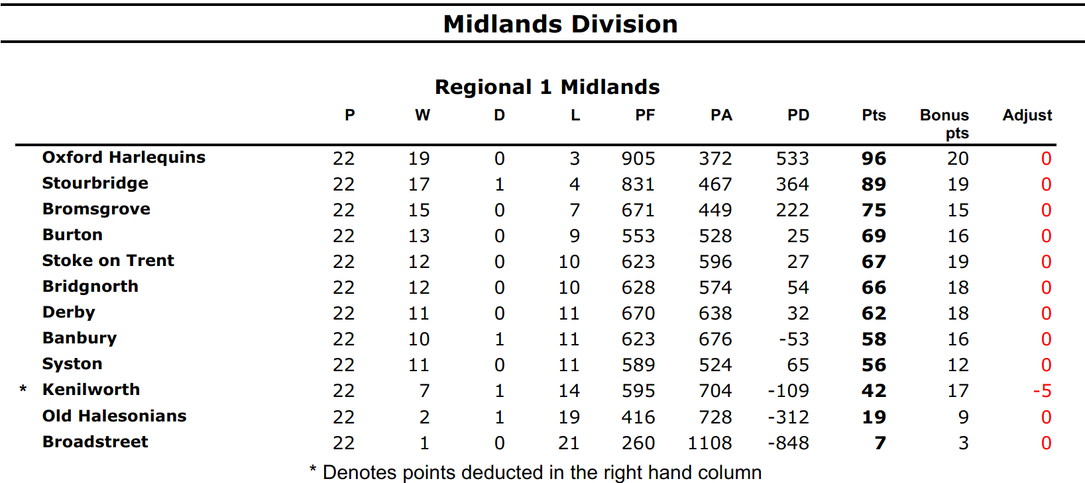

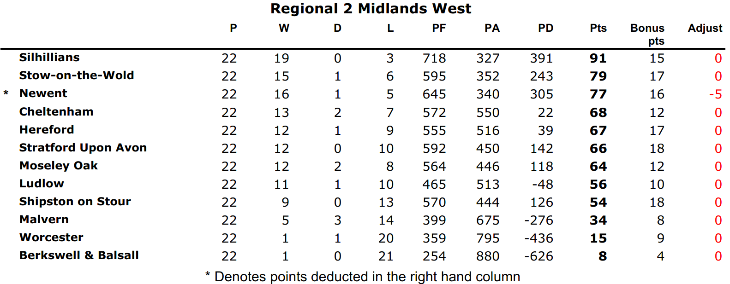

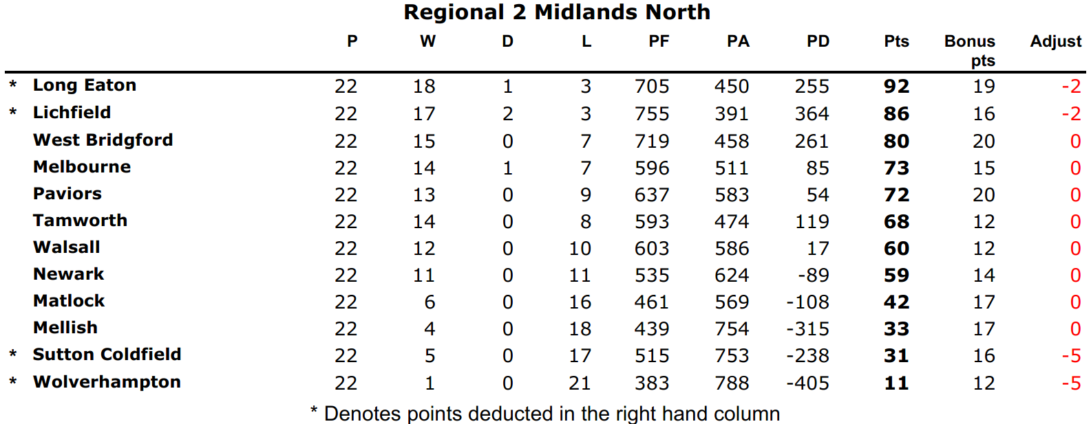

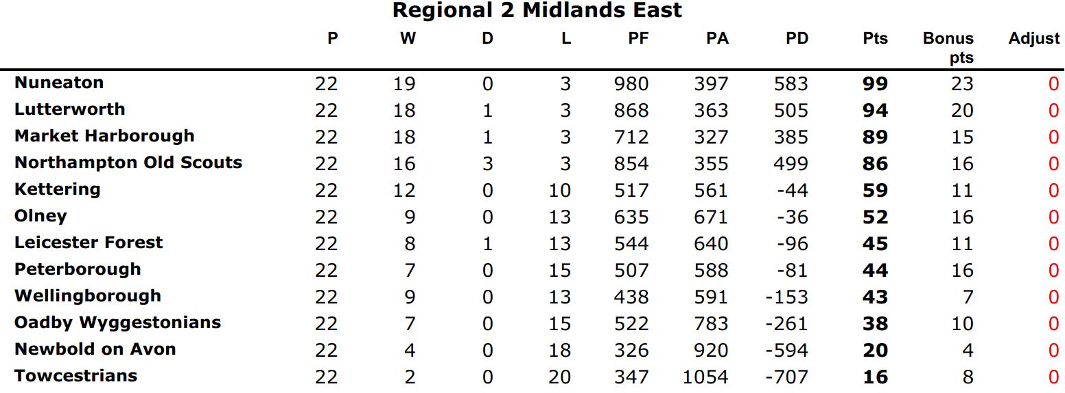

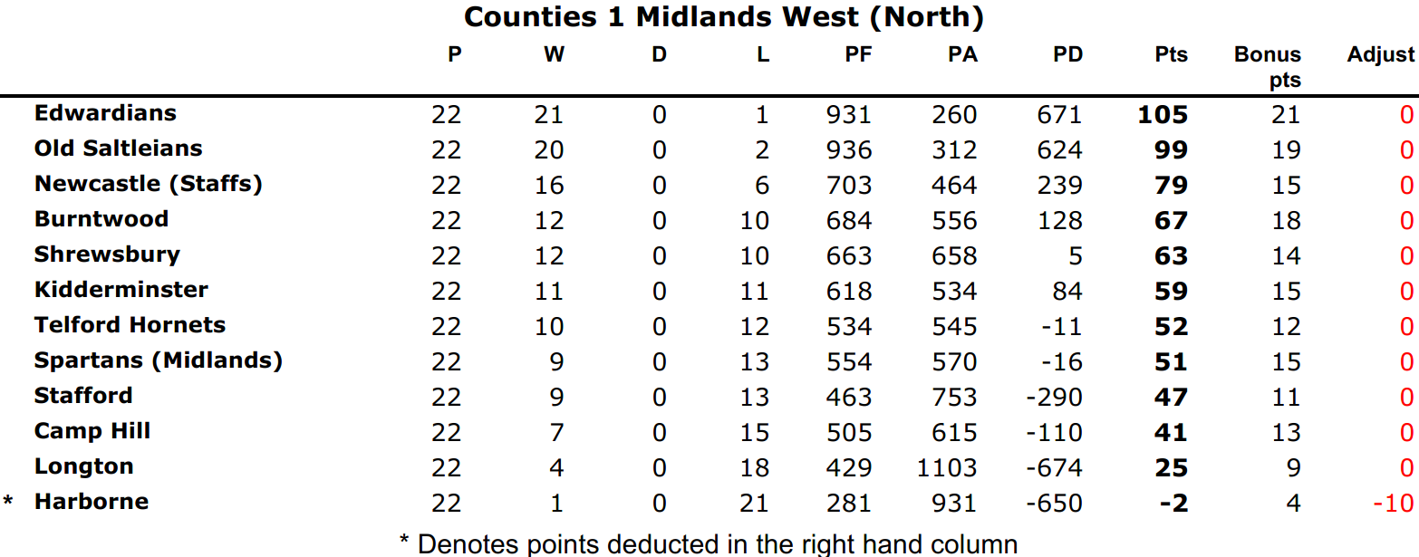

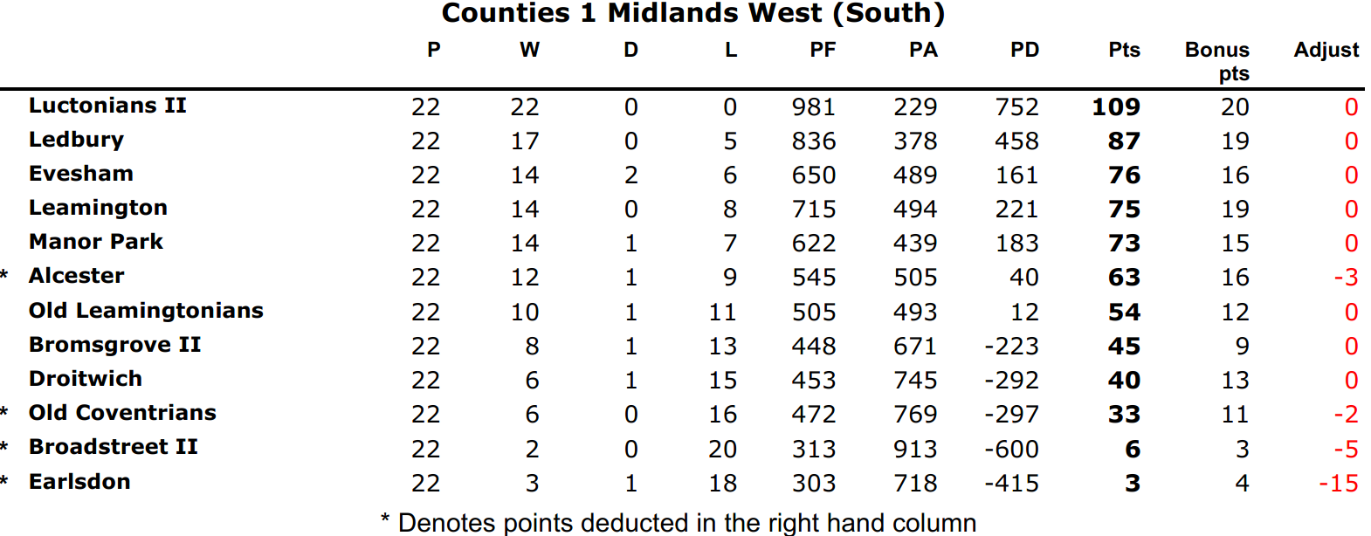

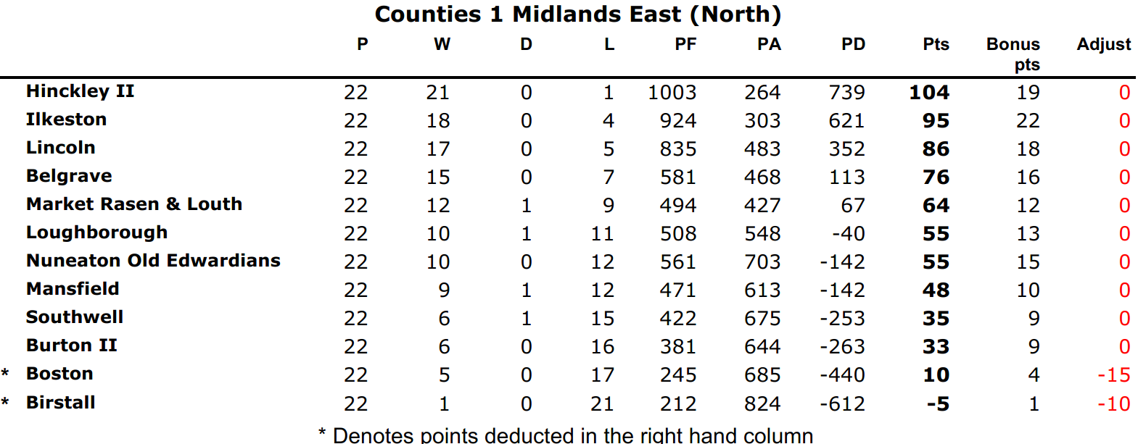

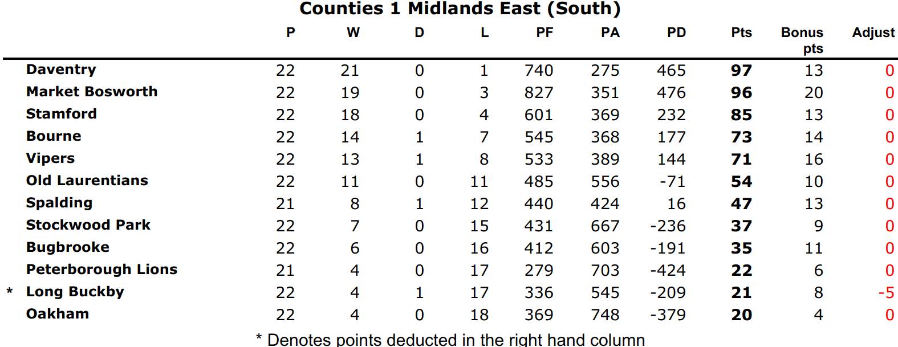

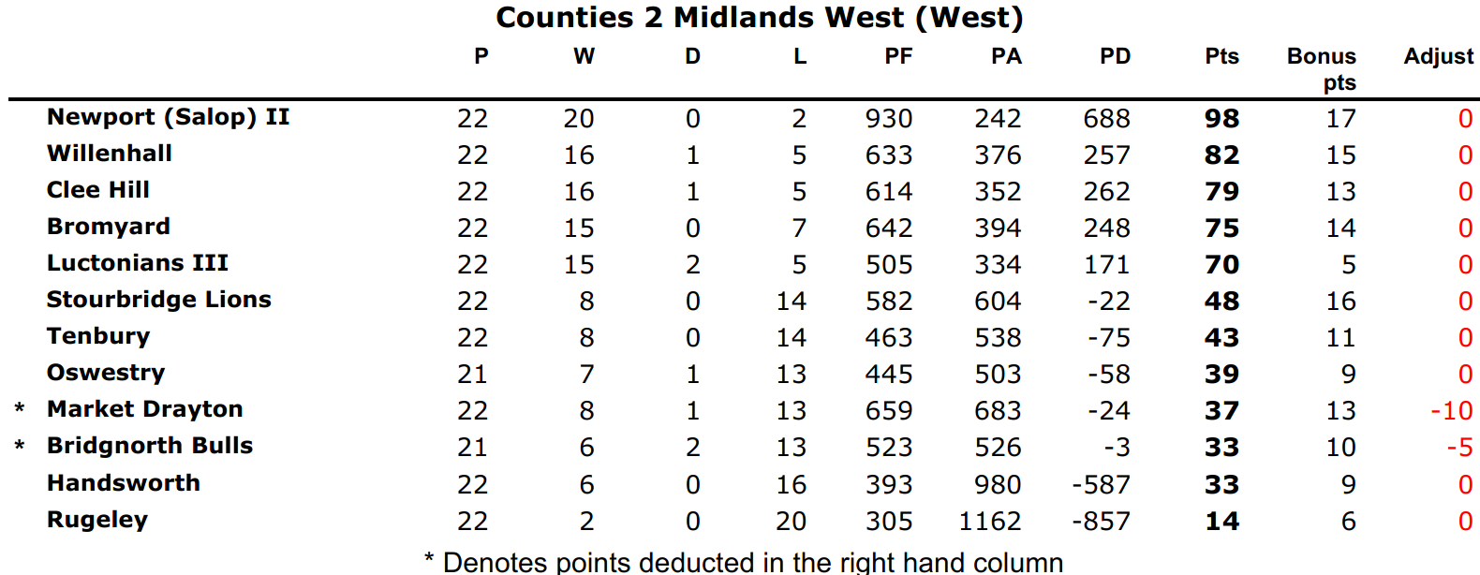

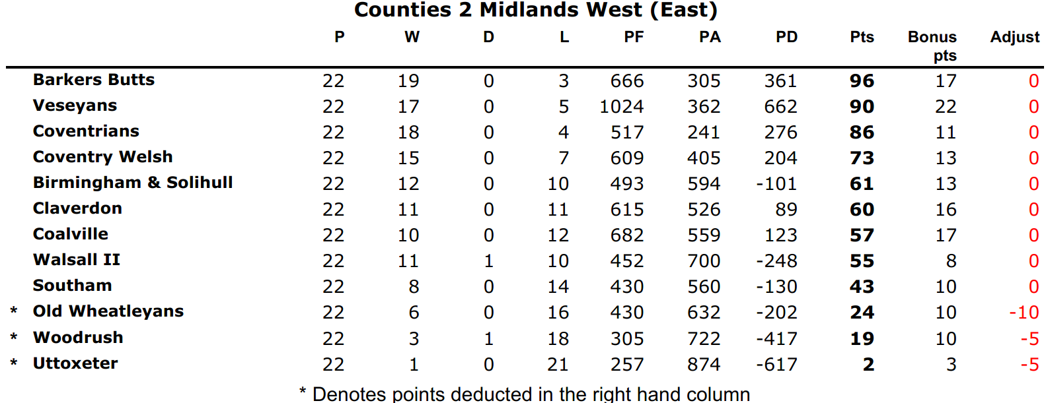

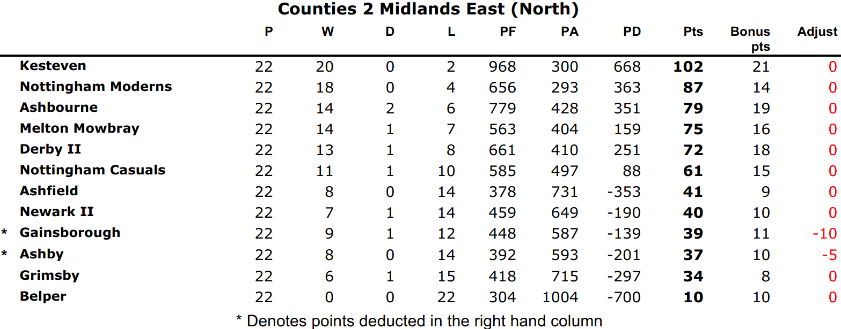

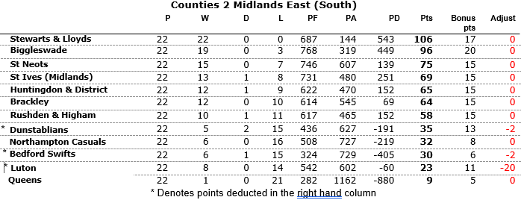

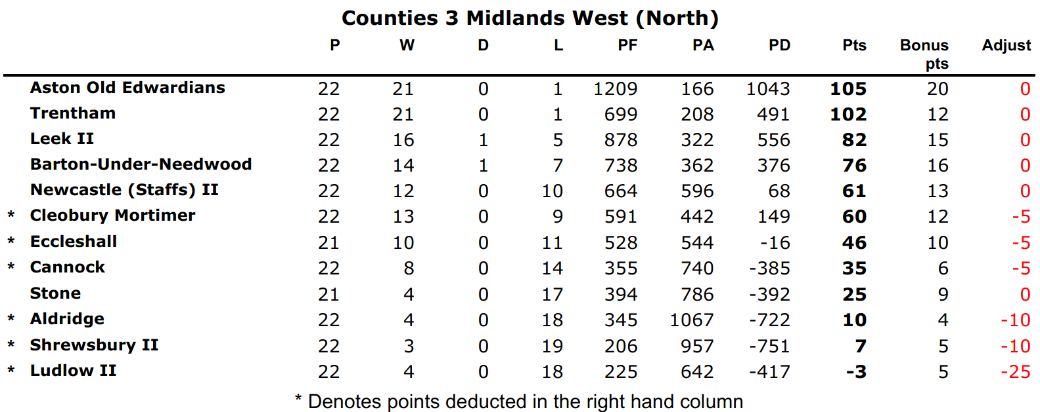

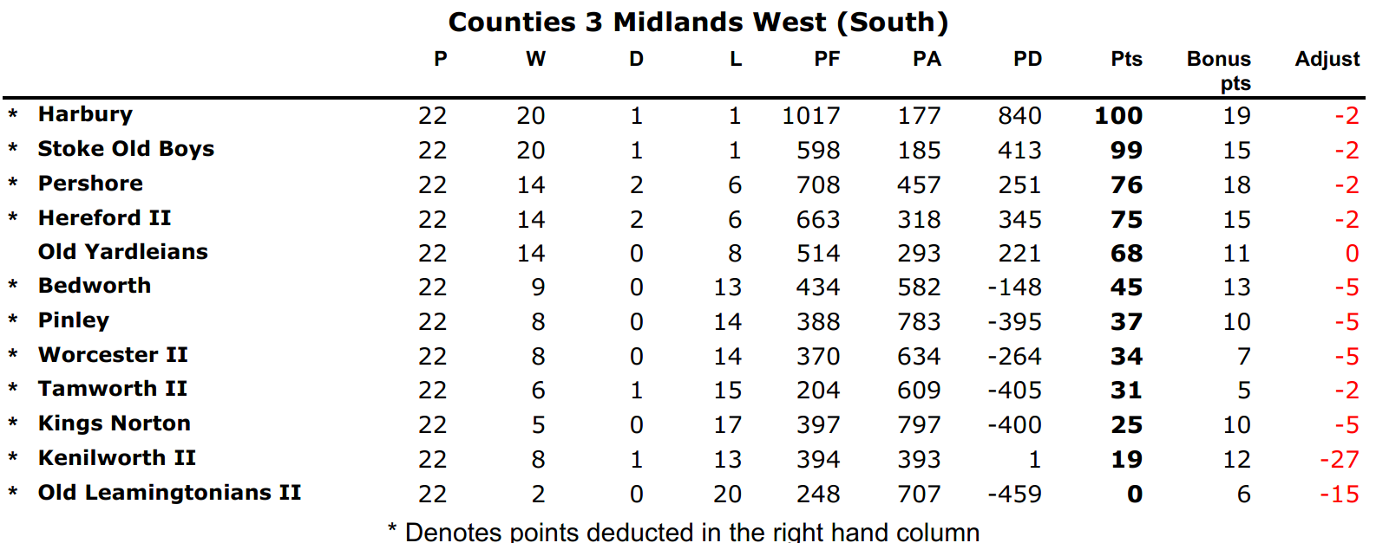

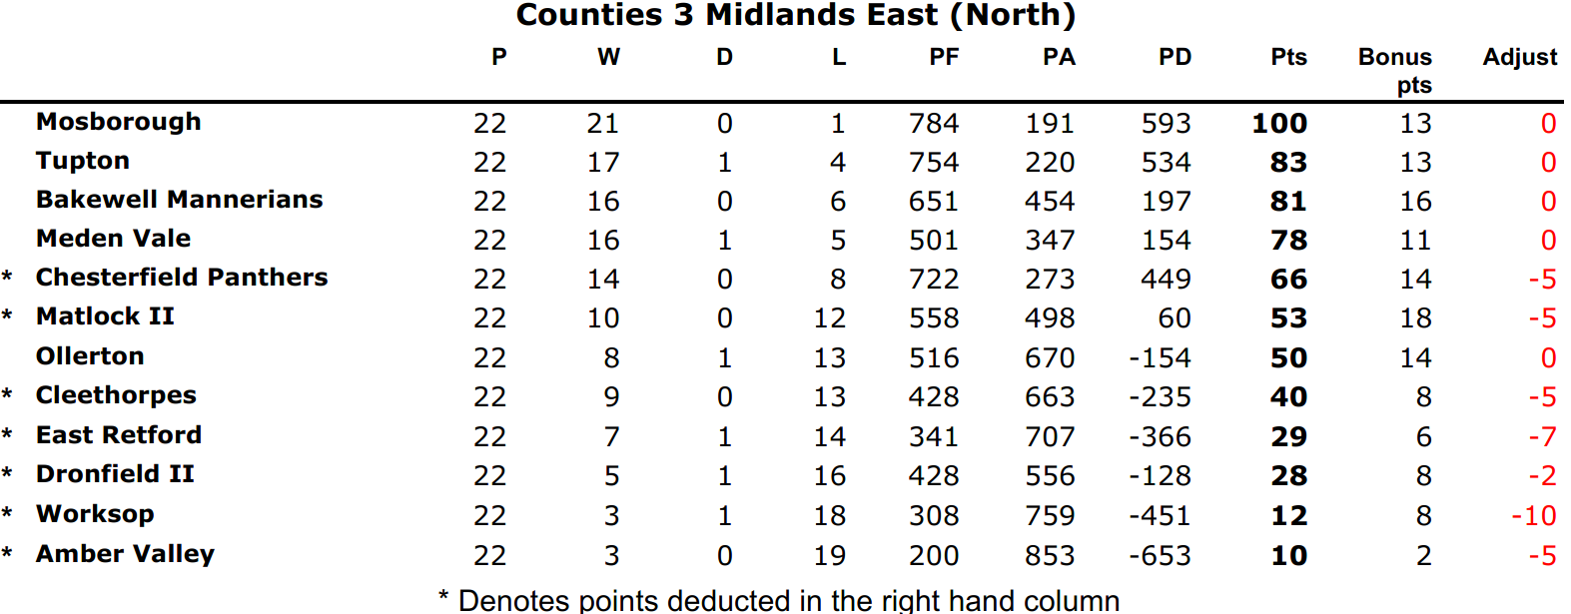

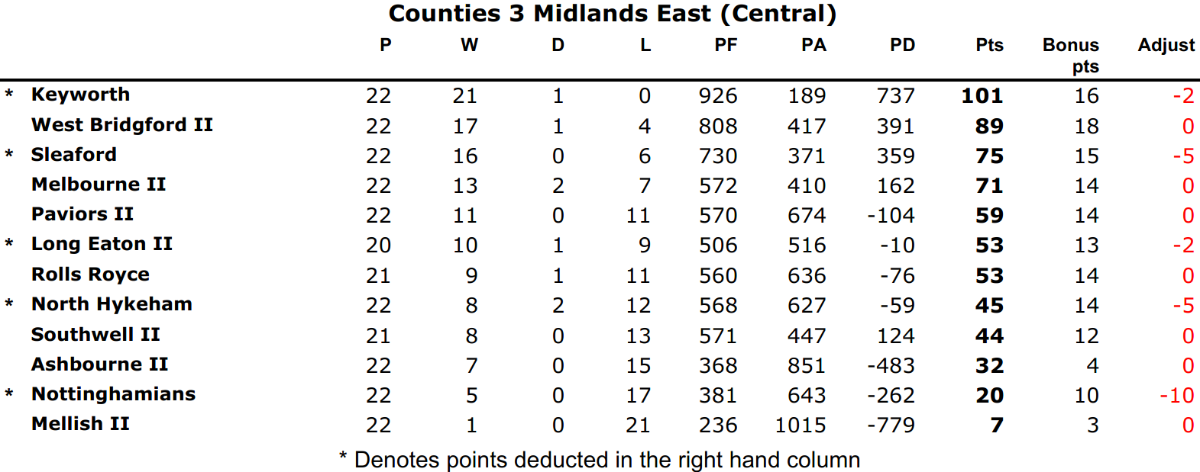

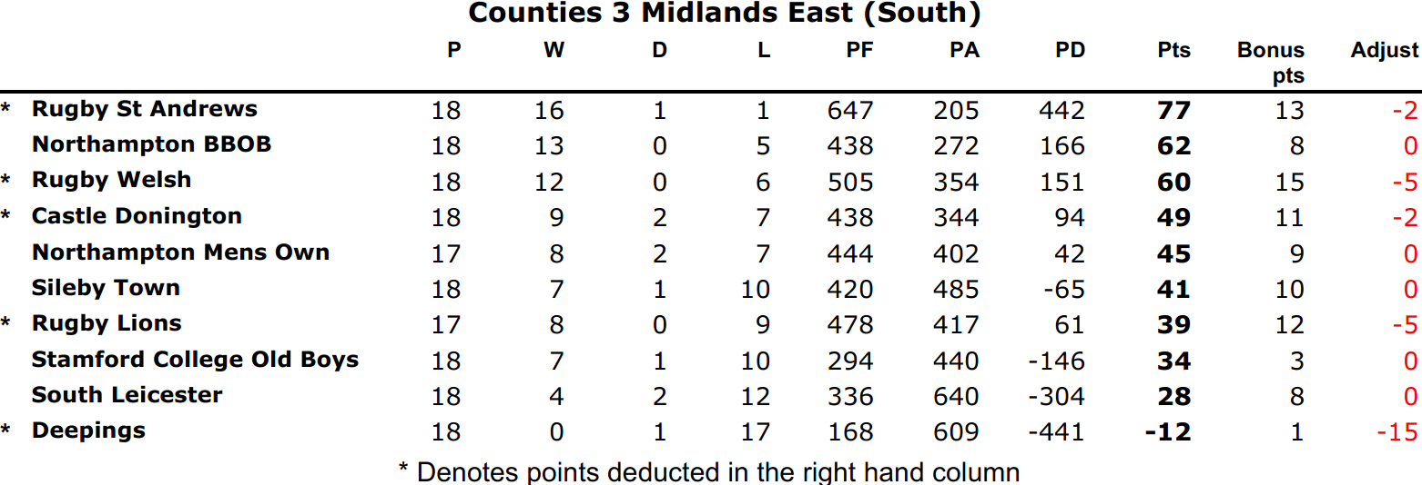

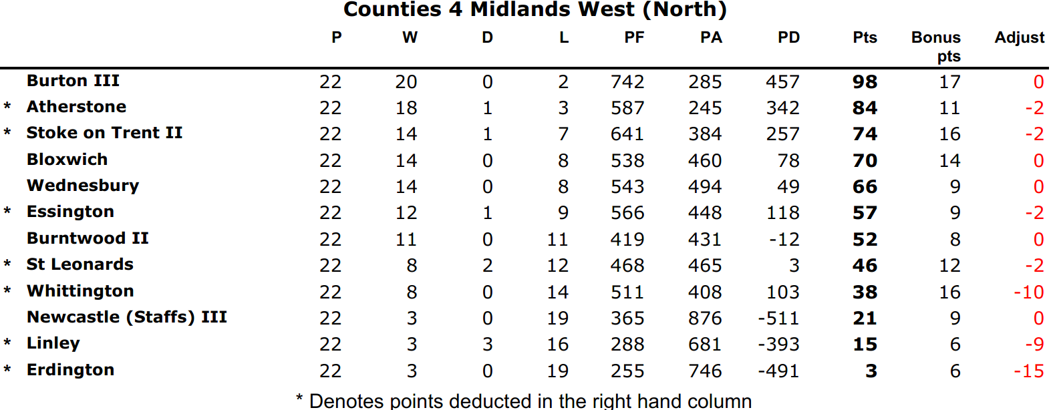

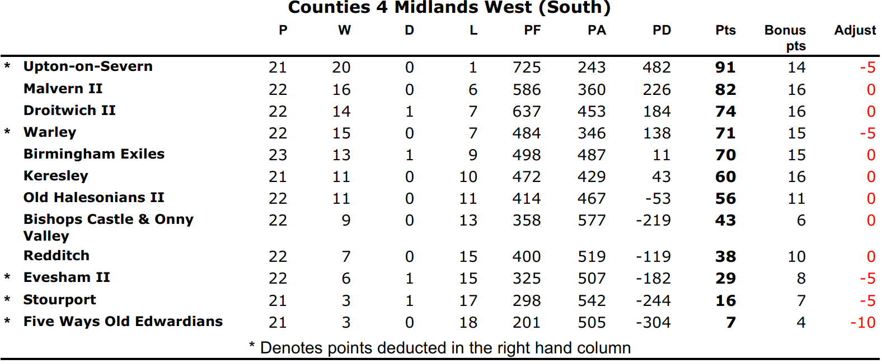

Northern Division

Regional 1 North West

 |  | P | W | D | L | PF | PA | +/- | TB | LB | Pts
1 | Macclesfield | 22 | 20 | 1 | 1 | 908 | 378 | 530 | 22 | 0 | 104
2 | Rossendale | 22 | 19 | 1 | 2 | 1081 | 402 | 679 | 21 | 2 | 101
3 | Blackburn | 22 | 16 | 1 | 5 | 877 | 435 | 442 | 19 | 2 | 87
4 | Wirral | 22 | 14 | 0 | 8 | 50 | 514 | 36 | 14 | 3 | 73
5 | Manchester | 22 | 13 | 1 | 8 | 528 | 519 | 9 | 11 | 2 | 67
6 | Kendal | 22 | 9 | 1 | 12 | 488 | 627 | -139 | 8 | 3 | 49
7 | Stockport | 22 | 8 | 0 | 14 | 448 | 611 | -163 | 9 | 4 | 45
8 | Penrith | 22 | 7 | 0 | 15 | 504 | 751 | -247 | 10 | 4 | 42
9 | Anselmians | 22 | 7 | 2 | 13 | 382 | 653 | -271 | 6 | 3 | 41
10 | Leek | 22 | 5 | 1 | 16 | 483 | 658 | -175 | 4 | 7 | 33
11 | Sandbach | 22 | 5 | 0 | 17 | 395 | 680 | -285 | 5 | 5 | 30
12 | Northwich | 22 | 5 | 0 | 17 | 390 | 806 | -416 | 5 | 1 | 26
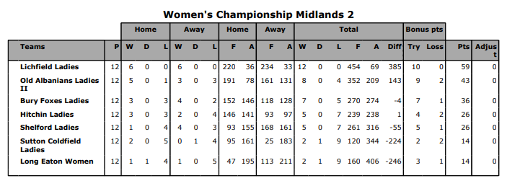
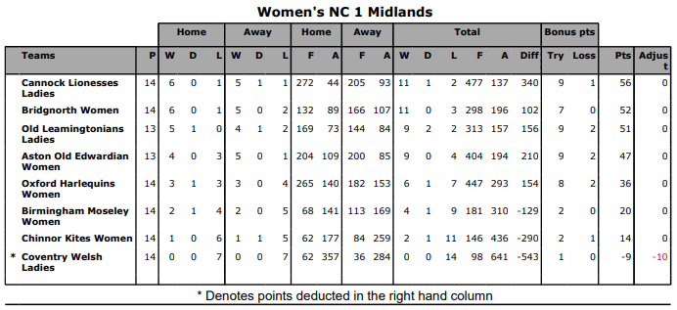

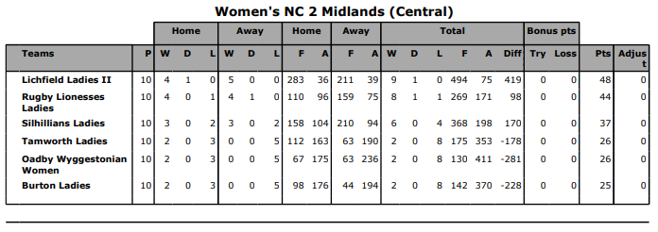

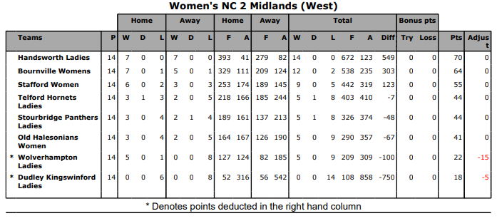

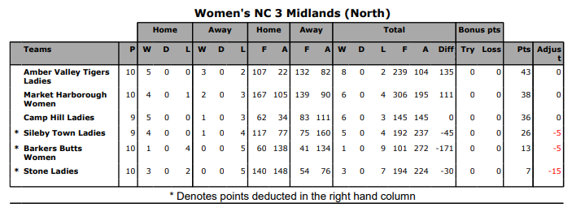

Produced by RW Print Designs ©

