STAR* SCHEME HAS PARTNERED

WITH STAFFORDSHIRE RUGBY

star* scheme launch event

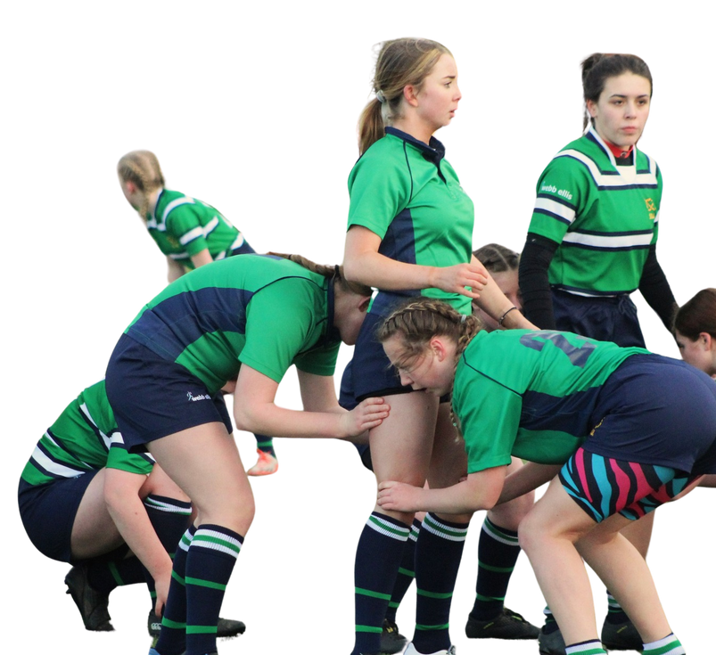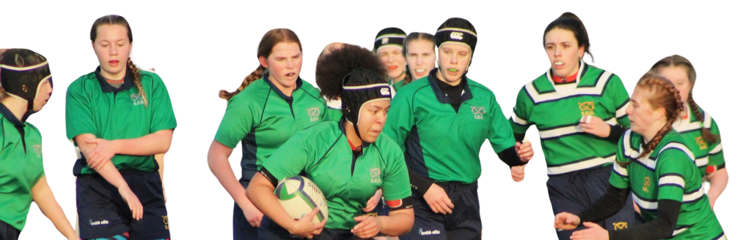

Stafford RFC President’s Lounge

Wednesday 19th February 2025

6:30pm - 8:00pm

& includes food

Come along and discover how your club can

participate in this exciting initiative & book a ticket

Our mission is, to make a material difference in the lives of young people and their families who have multiple adverse childhood/ community experiences (ACEs) or mental health issues.

Click the link below to hear [star scheme story](https://youtu.be/NOGILzSYrcI?si=2kf5IrC6-KopbjLH)